**Turn Off Async Services in OQS**

1-Login to jconsole, select remote process & give the server name where you want to turn off Async services

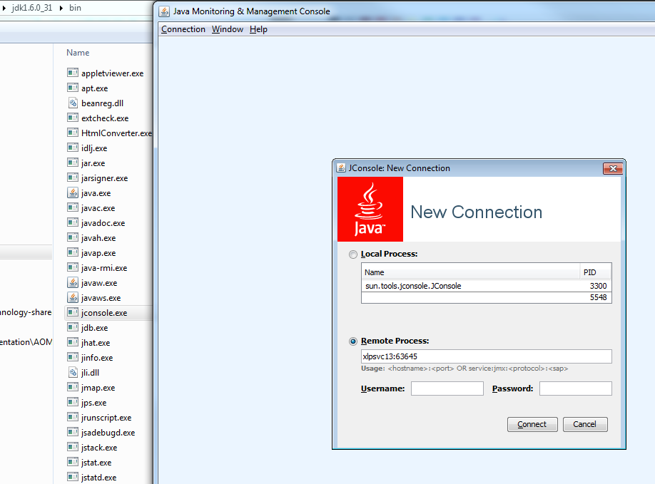

2-Check the port number for the deployed OQS build from OQS Wiki.

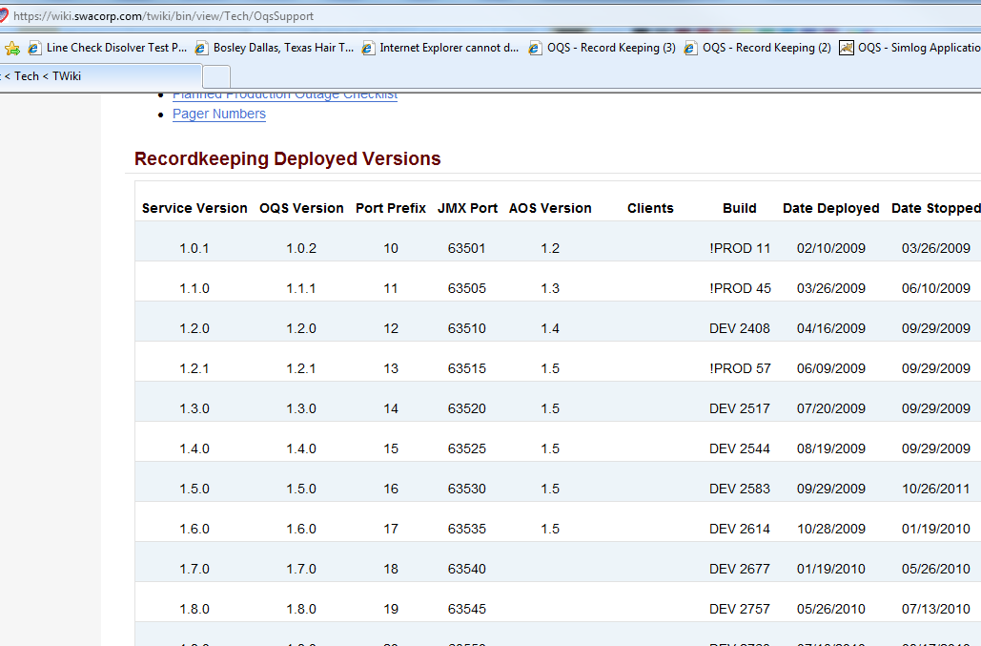

3- Verify if **Stopped** Attribute is false or true & take action accordingly.

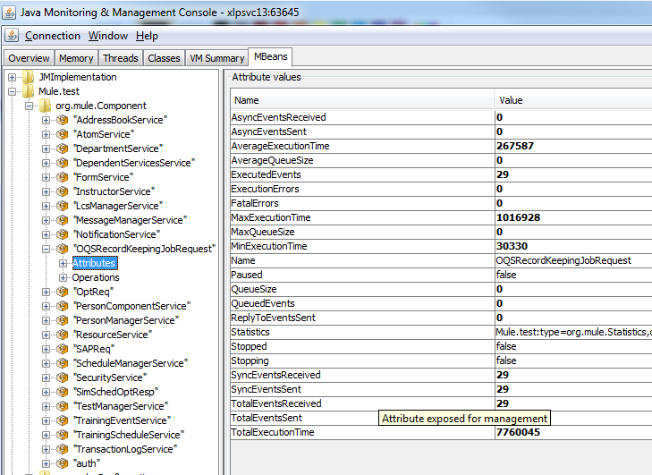

4- Select Operations & click on stop & start accordingly.

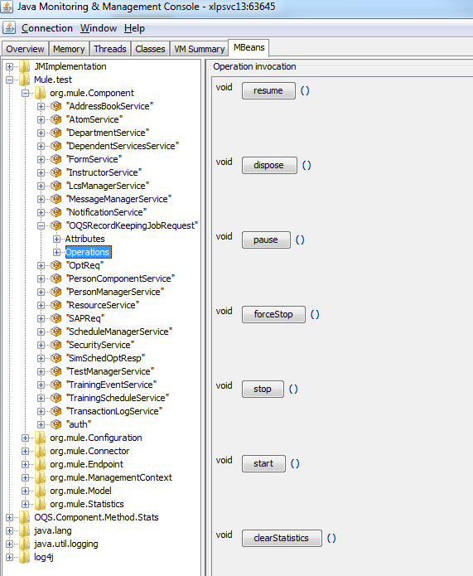

5- Async Service running on xlpsvc 13.

OQSRecordKeepingJobRequest

OQSSimLogJobRequest

OptReq

SimSchedOptResp

SAPReq

5- Async Service running on xlpsvc14.

OQSRecordKeepingJobRequest

OQSSimLogJobRequest

OptReq

SimSchedOptResp

SAPReq

CssBaseChange

Note: cssDisqual Async service is not in use any more.

